**Soil Biology, Soil Health and Soil Testing Field Day**

Please join Western Local Land Services, The Rangelands Living Skin Project and Rangelands Network for Soil Knowledge Project for a field day / workshop on these interesting topics.

At this day we will present some simple methods to assess and understand soil condition and productive potential. We will look at various soil types, their properties, and indicators of soil health. We will discuss the resilience of different soil attributes, and how management can influence rates of change. We will cover the basics of soil biology – the unseen powerhouse in the soil, its functions, and what you can do to look after it, so it can maximise its potential.

Oliver Knox, soil scientist from UNE Armidale, and Karl Andersson, soil scientist with NSW DPI, will be our presenters.

Participants will be shown how to take representative soil samples, and all participants will get access to soil sampling gear on their own properties. There is also the opportunity for a limited number of fully subsidised soil tests to measure soil nutrients, including soil carbon. The day will be mostly outside looking at local soils, with plenty of opportunity for discussion on local soil issues, plus Q&A.



Region:

Western

Date and time:

**Wednesday, 2nd November, 9 am – 3 pm**

**Location: Wilcannia**

**‘NETALLIE’, Wilcannia, NSW**

From Broken Hill- drive east 180km. At the bottom of the Netallie Hill rest stop turn left at white mail box. Windmill on the right.

From Wilcannia- drive west 20km. At the bottom of the hill before the Netallie Hill rest stop turn right at white mail box. Wind mill on the left.

Head down drive way approx 2km.

Lunch provided

RSVP:

Saturday 29th October

Contact:

Casey Harrison

Land Services Support Officer

0460 634 538

[Casey.harrison@lls.nsw.gov.au](mailto:Casey.harrison@lls.nsw.gov.au)

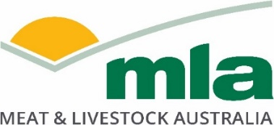

These projects are jointly funded through NSW DPI and MLA and the Australian Government’s National Landcare Program.