MLA Producer Demonstration Sites

Communications guide

Contents
1. Communication activities 3
2. Project key messages 4
3. MLA brand guidelines 5
4. Article guidelines 9
5. Photography guidelines 10
6. Media 12
7. Events 13
8. Social media 14
9. Communications plan 15
Appendix A: Case study template 16
Appendix B: Completed producer case study template 17
Appendix C: Event flyer template 21
Appendix D: Image release form 22
Appendix E: MLA video guidelines 23
Appendix F: Communication plan template ……………………………………………………………………………………………….24

Communication activities
Communication activities carried out by Producer Demonstration Site (PDS) participants are to ensure both the relevant local producer community and the broader industry:
- are informed of the project
- understand its value
- can access information about the project and its progress.
A minimum level of communications activities need to occur to contribute to the awareness levels of MLA’s PDS program.
This will be evidenced by the number of producers (particularly those from the local region) engaging with the project via a variety of channels, including:
- field days or workshops held at the Producer Demonstration Sites
- a project site sign hung on the farm gate for core producers running a demonstration site, if located in a high traffic area
- reading about the progress and results in producer newsletters, email updates, social media and group websites
- reading about the progress and results in MLA’s communications channels, which include Feedback magazine, YouTube, other online content and social media as required.
Cases studies are required to be developed for each demonstration site throughout the life of the project for circulation within the core and observer producer groups as well as wider industry networks.
Accessing MLA Feedback magazine for delivery of case studies is available to all projects. If the group wish to use feedback magazine, the project facilitators is to complete the case study template provided in Appendix A so MLA can develop case studies in years two - six to report on how producers are responding to the project. These case studies will also be a valuable resource to distribute through your networks.
Participants should also be available for photographs, filming and interviews, which can be used by MLA channels.
It is expected groups will collect and provide basic information about producer engagement to MLA as part of the milestone reporting cycle. This includes:
- the number of producers attending events where the project has been showcased and any feedback (either qualitative or quantitative) on its perceived value
- the number of producers receiving the Producer Demonstration Site’s group newsletter or, if it is an electronic newsletter, how many have opened and clicked through to more information on the project, where there is an opportunity for this to occur.

Project key messages
When developing communication activities focus your content on the following key messages:
- A clear description of how the project will benefit local producers i.e. the on-farm benefits.
- The project involves a partnership between <Contracted Party> and local producers to demonstrate research findings on commercial properties (include name of project facilitator and organisation).
- The X-year project was initiated by (insert producer group).
- Producer Demonstration Sites are funded by MLA to support producer through peer-to-peer groups to pursue new skills, knowledge and management practices applicable to their own commercial livestock production systems.
- Ensure the text ‘This Producer Demonstration Site is funded by Meat & Livestock Australia’ is included on all communication materials. In the case of Co-contributor PDS, this statement would be expanded to include the other contributors ie ‘This Producer Demonstration Site is funded by Meat & Livestock Australia and xxxxx’. Please note Meat & Livestock Australia is spelt with an ‘&’ and not the word ‘and’.

MLA brand guidelines

MLA’s brand and style guidelines provide direction on how MLA’s brand is to be represented internally and externally. The guidelines must be strictly followed to ensure the brand is used consistently across all mediums, both alone and in conjunction with multiple partner brands and programs. The guidelines have been developed to reinforce MLA as a professional company and ensure MLA is recognised for the work it invests in.

MLA logo
The MLA logo is the most identiﬁable element of our brand identity. Consistent application of the element strengthens the MLA identity across all our communications.
- always use the full colour version of the MLA logo wherever possible
- keep all elements of the logo in the relationship shown
- do not recreate or alter any aspect of the logo
- do not change the colours of the logo
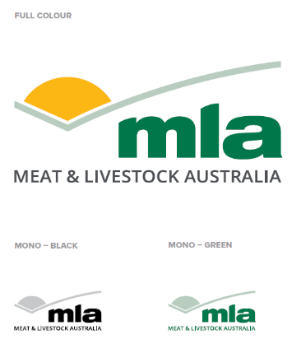
- use the full colour version of the MLA logo on a white background.
Colour versions
There may be situations where, due to design or production constraints, the full colour version is not appropriate. In those instances the mono or reverse versions of the logo are also acceptable but less preferred.
- Use the reverse (white) version when the MLA logo appears on a dark background.
No other versions should be used.
File formats
Logos are available in both PNG and EPS formats. External designers and suppliers will require different ﬁle formats depending on the end product, in order to supply the correct format, the general format requirements are shown below.
- PNG format for digital, web and Microsoft Office applications.
- EPS (vector) format for printing, large format display and signage.
Do 
- use the current version of the MLA logo
- maintain correct proportions of the MLA logo
- maintain clear space around the MLA logo
- use the right ﬁle format for the task.
Don’t 
• recreate any aspect of the MLA logo
• alter or distort the MLA logo
• change the colours in the MLA logo
• place the MLA logo on a busy photograph or heavily patterned background.

Logo spacing and size

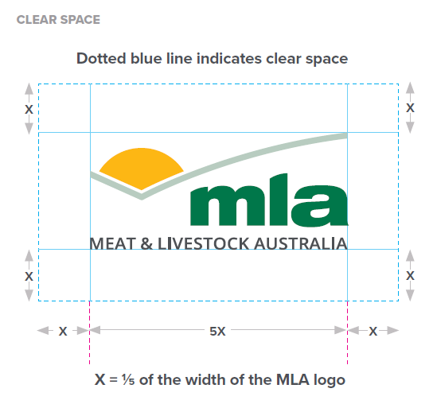
Clear space
To maintain the visual integrity of the logo, clear space should be maintained around the logo where no copy or design elements intrude. All other logos should appear outside this zone. The only exception is where a sub brand is used. In this case the sub brand title is set within the exclusion zone and the clear space is applied around the sub brand.

The clear space around the logo on all sides = X and is determined proportionally to the size of the logo as shown.

X = 1∕5 of the width of the MLA logo

Minimum size
A minimum size of 20mm logo width is recommended so that the logo remains clear and readable. The logo may be scaled proportionally to any size larger than this.

Printed front cover size and position
When the logo appears on the front cover of an MLA owned document, the recommended MLA logo size is shown below. For other print applications such as advertising or banners, the MLA logo can be sized proportionally to suit the situation and retain a similar look.

Logo size on a front cover
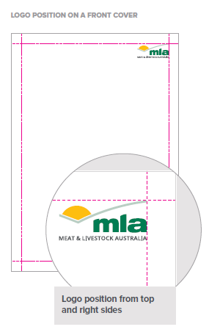
DL – 33mm wide
A5 – 36mm wide

On a page
A4 portrait – 40mm wide
A4 landscape – 42mm wide

Position the logo in the top right corner of the front cover as shown. On an A4 portrait cover the logo is 40mm wide and is positioned at the top and right sides. In some situations it will be necessary to apply discretion to the logo size and position, this should be guided by the content (e.g. marketing material, advertising and newsletters).

Logo placement
The MLA logo will appear in a variety of situations either by itself or with other logos in partnership or as a sponsor. For consistent branding, a structured system of logo placement in brand areas should be adhered to.
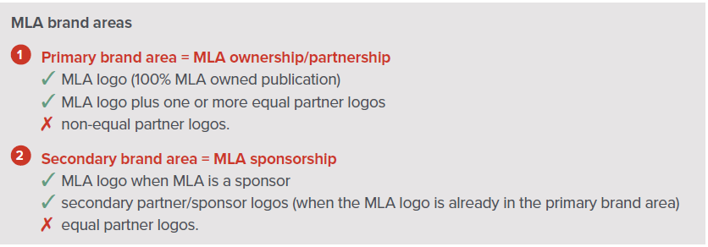
The MLA logo placement reﬂects the varying degree of involvement of MLA and its respective partners. The table on the right denotes logos that can ✓ (or can’t ✗) appear in the designated MLA brand areas for ownership and sponsorship.

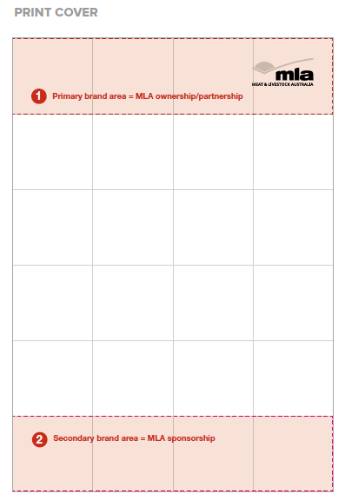
Print publication front cover
- in the primary brand area the MLA logo must appear on a white background
- in the primary brand area the MLA logo should appear in the top right
- where MLA is a sponsor or supporter the MLA logo should appear in the secondary brand area
- clear space around the MLA logo must be maintained
- the logo of the producer group involved in the PDS would appear in the secondary brand area

In some situations, it will be necessary to apply discretion to the position of the logo, this should be guided by the content and the minimum type-safe area (e.g. marketing material, advertising, magazines and newsletters).

Producer Demonstration Site logo
MLA has two versions (horizontal and vertical) of the Producer Demonstration Site (PDS) logo which can be used on PDS communication materials alongside the MLA logo.

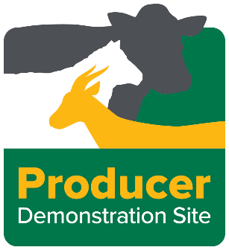

Where MLA owns a program (e.g. Producer Demonstration Sites, Proﬁtable Grazing Systems or BeefUp Forums), it’s necessary to demonstrate MLA’s involvement in the program by promoting both the MLA logo and the program logo alongside each other.

Here’s where to place the logos if:

MLA is the primary funding organisation
In instances where MLA is the primary funding organisation, the communication material must show the MLA logo in the primary brand area on the right-hand side of the page (see ‘Logo placement’ above). The program logo should also appear in primary brand area on the left-hand side – see Examples A and B.

MLA is not the primary funding organisation
If MLA is not the primary funding organisation, the MLA logo and program logo don't have to appear in the primary brand area. The logos can be placed side by side in the secondary brand area – see Example C.

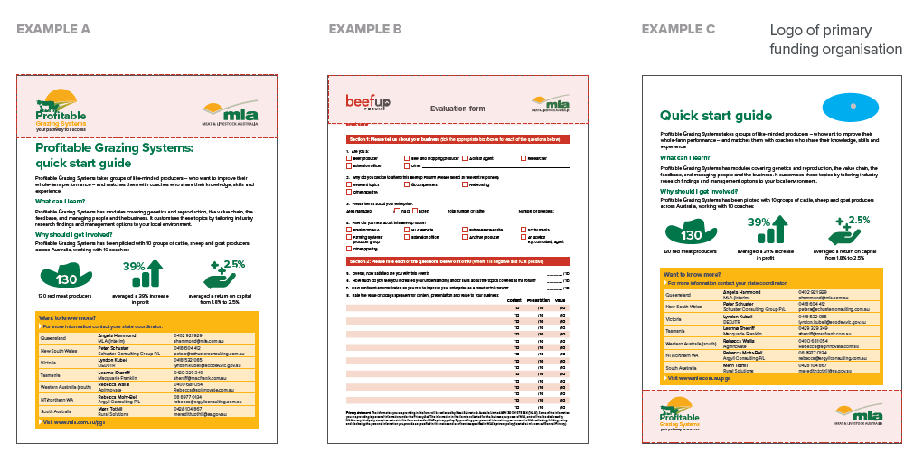
To request a copy of the MLA and PDS logo please contact:
MLA’s content development team - E: brief@mla.com.au
MLA PDS Project Manager – Alana McEwan, E: amcewan@mla.com.a

To download a full copy of the MLA Brand guidelines go to mla.com.au/comms-hub

Article guidelines
If you have written an article about your Producer Demonstration Site please send it to the MLA PDS Project Manager and your PDS Coordinator. Following a technical review, the article will be submitted to MLA Communications team to review and check branding and MLA’s role is outlined. Please allow at least three working days’ notice for these checks.
Here are 10 tips for writing an engaging article:
      - Purpose: Have a clear reason for the communication and know who the reader is – understand who they are and why they would be interested in the communications.
      - The hook: In the introduction reel out a hook and/or a compelling reason to continue reading – if the hook isn’t apparent, reconsider the purpose of the written communications.
      - Getting engagement: Provide information in a clear, succinct and engaging way – omit unnecessary words, consider visual elements (images, graphs, infographics etc.) and breakout boxes.
      - Key messages: Place key messages upfront – never assume someone will read to the end.
      - Use sub headings: Help the reader easily read the article by using sub headings to break the body copy into small digestible pieces.
      - Bullet points: Are a great way to list key information in an easy-to-read format.
      - Acronyms: Make sure you always spell out any acronyms in the first instance. Although the acronym may be obvious to you, the reader may not understand.
      - Avoid technical language: Keep the language simple and not too technical, avoid complex industry jargon and keep your target audience in mind when writing the article. Write for the reader and the reader alone.
      - Proofread: Review your article to remove any spelling or grammatical errors. Ask a colleague to help proofread your article as a fresh pair of eyes always helps.
      - Call to action: Include a clear call to action – contact details, an event, a website etc.

Photography guidelines

Photos for media and publishing
- Photos will be useful to accompany media releases and for MLA’s publications.
- You don’t need a fancy camera but avoid using the camera on smartphones.
- Low resolution photos (suitable for the web) cannot be used for commercial publishing. Make sure your camera is set to take high resolution photos (300dpi). As a general guide, jpeg photo files need to be a minimum of 2MB to be suitable for publishing in commercial print media.
- When you take photos with people in them, explain that they may appear in a variety of places including the media, reports and presentations to industry and ask them to sign the MLA image release form (see Appendix D). MLA will not publish photos without a signed image release form.
- While technical photos are important for tracking project progress, they can be visually boring from the perspective of media or magazines. Here are some tips to make photos more interesting for publishing:
    - Include a human ‘element’ – for example, a hand in a close up of pasture provides a sense of scale and some visual diversity or include a producer kneeling down inspecting the pasture.
    - Take the photo from different angles, for example, kneel down or stand on a ladder so it is slightly different to the way we would normally look at the scene (front on, at eye height). It is a simple but very effective strategy.
    - Use the zoom to take the same shot at different distances.
    - If possible, include animals.
    - If taking field day shots, take them with people looking at you and ask them to take off their hats or sunglasses before having their photo taken.
    - If people are in the photo, take several shots – if their eyes are shut in one pic, chances are, another will be better.
    - Make the most of the opportunity – take some scenic shots (as well as the specific shots you think you need). Scenic shots always come in handy. E.g. the herd or flock grazing (or a farmer walking through paddock) with hills in the background (or trees in the foreground); anything with sunset/sunrise/interesting clouds.

Tracking project progress with photos
Please collect quality photographs that can be featured in reports, presentations and on MLA’s website that show key elements of the group project. While these may not be as visually interesting, they can show differences between treatments that occur over time.
MLA has requested that approximately three photos be featured in each milestone or final report with digital copies provided to the Producer Demonstration Sites State Coordinators. These will be forwarded to MLA.
Recommended photos include:
- photos showing ‘before’ and ‘after’ treatment
- fixed point photos taken of treatments to show changes over time, particularly for each season or before and after treatment (make sure you take the photo from the same position each time to make it comparable)
- general photos of the paddock or activities e.g. sheep grazing the pasture, weighing stock, etc.
- photo showing trial site layout
- positive, non-identifying photos of producers (unless permission is sought) during site visits or field days
- fence-line comparisons
- environmental events such as water-logging/pugging or dry seasons
- representation of different land-classes on the site
- close-ups of pastures at different growth stages
- pasture composition
- measurements of feed on offer and ground cover.

Media
Producer Demonstration Sites may consider using media to communicate progress and advertise field days.
If groups would like to inform local media about upcoming events/trials, here are the steps to take:
- Advise MLA of any media outreach planned through the MLA PDS Project Manager and provide a copy of what materials are being distributed. (Note: in a majority of cases MLA won’t have any changes to make.) The MLA PDS Project Manager will inform MLA’s Media Manager.
- Acknowledge MLA and the PDS program in any communications that are distributed (refer to section 2 of this document for exact wording).
Tips to increase exposure via media
- Compile a list of local media outlets (print, radio and newspaper) to distribute communication materials to via email.
- Identify a spokesperson for the group to speak to the media and follow up any email distribution of media releases with a phone call, offering an interview.
- Get to know your local ABC rural reporter. An ABC rural interview can help encourage people to attend events.
- Have an engaging hook for media (ie. not just holding an event). The hook can be as simple as the event is free or can be more significant by offering what they will learn or get from the day or a notable speaker.
- Give plenty of notice for events and follow up with more communications closer to any event.

Events

If you are hosting an event such as a field day or a webinar please contact the MLA PDS Project Manager to ensure all relevant MLA event approvals have been confirmed.

If you would like to increase exposure for your event through MLA’s channels, here is the process to follow:

Complete the MLA PDS flyer template (Appendix C) and email to the MLAPDS Project Manager and your PDS Coordinator.

The MLA PDS Project Manager will share this with MLA’s events team who will:

share to the MLA events page

email to MLA members in the relevant region.

For events where MLA is the primary funder please refer to the events flyer template in Appendix C

Social media
Social media is a great way to generate awareness of Producer Demonstration Sites and communicate progress as well as advertise field days.
To increase engagement on all social media platforms, make sure you tag relevant groups, individuals and MLA. Below are some more tips to ensure success when using each social media platform.
Facebook:
- Keep the post short and engaging to capture attention
- Include a call to action such as ‘attend a field day’
- Use a good, high definition image, video or infographic to make your post stand out
- Provide a website link for the reader to find more information
- Post at peak times, which is usually during the evening.

LinkedIn:
- Optimise your page such as updating your profile image and banner, and write a compelling ‘about us’ section
- Share content once or twice per week to keep your audience engaged
- Aim for a skills-building angle with the content that you post
- Add showcase pages to provide more information to your followers
- Encourage other producers in your peer group to share the content created.

Twitter:
      - Keep your posts short (maximum 280 characters)
      - Use quality visuals where possible such as infographics and diagrams to capture attention
      - Only use one to two hashtags per tweet
      - Monitor events and trending conversations to keep your followers up to date
      - Retweet relevant content.

Communications plan

MLA has developed a communications plan template for PDS groups who have been requested to develop a communications plan as part of their project deliverables.

Complete the first draft of your communications plan using the template provided in Appendix F. Email your communications plan to MLA Project Manager – Producer Demonstration Sites, Alana McEwan (amcewan@mla.com.au) and your MLA PDS Coordinator. The PDS and Communications team will review and provide feedback within three business days.

To download a copy of the communication plan template refer to Appendix F.

Appendix A: Case study template
To download a copy of the MLA case study template visit mla.com.au/comms-hub
Publication through MLA communication channels will not occur without the approval of key people mentioned in the story, the key researcher involved and the MLA Project Manager. You may nominate other people that you wish to approve the story prior to its publication. Once the story has been completed, your group will have access to it and photographs, for publication in your own communication activities as you see fit.
Once you’ve completed the template, please email it to the MLA Project Manager – Producer Demonstration Sites program to review who will then send it to the communications team.
Topic
Key research question being investigated
Why answering this question is so important
Name of producer group
Name of researchers
What is interesting about this case study?
Lessons learned to date

Key/preliminary findings to date

Graphs that illustrate the key findings
Photos
- Please supply photos (as separate Jpeg attachments in high resolution at least 2MB); include the photo file names and captions in this document
Suggested photos:
- Producer (and family) with livestock in background
- Producer (and possibly researcher) examining the trial plot
- Producer group visiting the trial plots
- Anything else you think would illustrate the project well
Next steps
Interview contacts (name, email address and phone number)
- e.g. PDS coordinator
Site details: | Site 1 | Site 2 | Site 3 | Site 4
Location of site/s (GPS coordinates, nearest town and state)
Pasture type/s
Soil type/s
Enterprise type (cattle, sheep, etc)
Annual rainfall (mm)

Appendix B: Completed producer case study template
Topic | Sheep PDS
Key research question being investigated | Does finishing lambs on high quality forage crop and perennial pasture systems increase farm profit relative to store lamb systems?
Why answering this question is so important | This PDS confirmed modelled data, giving Monaro, NSW, producers confidence to pursue lamb finishing on specialised crops and pastures.
Name of producer group | Monaro Farming Systems Group
Name of researchers | Doug Alcock (Consultant)
What is interesting about this case study? | Farm profitability: With average net profits from establishing and finishing lambs on the pasture/crops ranging from $305/ha to $1,492/ha over the two years of the PDS.
Lessons learned to date | - Before selecting a forage pasture, consider the site, soil type, soil fertility status and long-term plan for the paddock.  - Good agronomic advice and good paddock preparation is critical.  - Aim for high dry matter production at high digestibility at the critical time of year – summer.  - Use the specialised pasture for finishing, don’t be tempted to use it for other purposes in the meantime.  - Using eID tags allows lamb weight to be easily measured more frequently to monitor growth and address problems quickly.
Key/preliminary findings to date | - The highest levels of production per hectare were achieved on systems where the crop was used solely for grazing lambs.  - Significant supplementary feeding resulted in good lamb growth rates, as well as very high rates of pasture utilisation.  - Allocating land to specialised lamb finishing can double or even triple its profitability, more than compensating any minor reduction in carrying capacity for breeding stock.
Graphs that illustrate the key findings | N/A
Photos  - Please supply photos (as separate Jpeg attachments in high resolution at least 2MB); include the photo file names and captions in this document  Suggested photos:  - Producer (and family) with livestock in background  - Producer (and possibly researcher) examining the trial plot  - Producer group visiting the trial plots  - Anything else you think would illustrate the project well | Photo 1 file name  FBDecJan-XX-LambFinishing001  Photo 1 caption  Plantain at Bibbenluke, NSW, November 2017.  Photo 2 file name  FBDecJan-XX-LambFinishing002  Photo 2 caption  Winfred brassica beside perennial ryegrass and white clover at Cathcart, NSW.  Photo 3 file name  FBDecJan-XX-LambFinishing003  Photo 3 caption  Lambs grazing Leafmore brassica at Mila, NSW, January 2019.  Photo 4 file name  FBDecJan-XX-LambFinishingDougAlcock001  Photo 4 caption  Graz Prophet Consulting’s Doug Alcock provided technical support to the project.  Photo 5 file name  FBDecJan-XX-LambFinishingAlexiAlcock001  Photo 5 caption  Budding agronomist Alexi Alcock helping dad Doug inspect a Pallaton Raphno brassica crop at Delegate River, January 2018.
Next steps | The performance of lambs on finishing crops with and without supplementary feeding will be the subject of another MFS PDS this summer.
Interview contacts (name, email address and phone number)  - e.g. PDS coordinator | Doug Alcock  E: doug@grazprophet.com.au
Site details: | Site 1 | Site 2 | Site 3 | Site 4
Location of site/s (GPS coordinates, nearest town and state) | Monaro, NSW | Delegate River, NSW | Cathcart NSW | Mila NSW
Pasture type/s | lucerne/phalaris/cocksfoot | Pallaton Raphno forage brassica | perennial ryegrass/white clover | Leafmore forage brassica
Soil type/s
Enterprise type (cattle, sheep, etc) | Sheep | Sheep | Sheep | Sheep
Annual rainfall (mm)

The following is an example of how MLA has converted the information in the case study template into an article:
Lamb finishing: is it worth it?
High-performance forage crop and perennial pasture systems were put to the test in NSW’s Monaro region in an MLA-funded Producer Demonstration Site (PDS) to see how finishing lambs stacked up compared to the traditional store lamb system.
The result was a tick for farm profitability, with average net profits from establishing and finishing lambs on the pasture/crops ranging from $305/ha to $1,492/ha over the two years of the PDS, despite poor seasonal conditions in the second year.
In comparison, the region’s traditional system of turning lambs off as stores by the end of December, at average sale weight of 29kg had an average total enterprise gross margin of $161/ha.
This PDS was run by Monaro Farming Systems producer group, with technical support from consultant Doug Alcock.
It followed an earlier project by Doug and the group, where they used GrassGro modelling software to quantify the benefits of finishing lambs.
It reflects changing enterprises in the region, which is traditionally a Merino grazing area.
“In the last decade, as wool prices waned in relation to sheepmeat prices, there’s been a lot of opportunistic joining to terminal sires or Border Leicesters,” Doug said.
“The vast majority of those animals end up in the store market, unfinished.”
Monaro Farming Systems chairman John Murdoch said the group invested in GrassGro modelling to quantify the relative profitability of retaining these store lambs and finishing them on specialised, high quality pastures.
“The modelling showed that in nine out of 10 years you’re going to be significantly better off, economically, by finishing lambs on specialised pastures,” John said.
The PDS was aimed at giving producers confidence these modelled figures could be replicated in real-life.
Real-world test
The PDS involved 10 paddocks on host properties with pastures and crops in the original modelling:
- lucerne/phalaris/cocksfoot
- lucerne
- perennial ryegrass/white clover
- Hummer fescue/white clover/sub-clover
- white clover/lucerne/chicory/plantain
- Winfred forage brassica
- Pallaton Raphno forage brassica
- Leafmore forage brassica
- plantain/chicory
- chicory/plantain/white clover.
All paddocks were grazed with weaned crossbred lambs, with 50 in each mob eID tagged as a monitor group for weighing.
Takeaway messages for producers from the PDS include:
The highest levels of production per hectare were achieved on systems where the crop was used solely for grazing lambs.
Significant supplementary feeding resulted in good lamb growth rates, as well as very high rates of pasture utilisation. (The performance of lambs on finishing crops with and without supplementary feeding will be the subject of another MFS PDS this summer.)
Allocating land to specialised lamb finishing can double or even triple its profitability, more than compensating any minor reduction in carrying capacity for breeding stock.
“As the PDS wasn’t conducted under strict pasture trial conditions, the systems cannot be directly compared to each other,” Doug said.
“However, the results indicate producers on the Monaro should feel confident in the reliability of increased profit from lamb finishing, regardless of the pasture/crop system chosen.”
Five tips for finishing lambs on pastures
- Before selecting a forage pasture, consider the site, soil type, soil fertility status and long-term plan for the paddock.
- Good agronomic advice and good paddock preparation is critical.
- Aim for high dry matter production at high digestibility at the critical time of year – summer.
- Use the specialised pasture for finishing, don’t be tempted to use it for other purposes in the meantime.
- Using eID tags allows lamb weight to be easily measured more frequently to monitor growth and address problems quickly.

Appendix C: Event flyer template

<Insert Project Title>
Producer Demonstration Site - <Insert event type i.e. Workshop, field day, field walk etc>
WHAT <Insert Details>
WHEN <Insert Date - Friday 15 June, 2019> | <Insert Time - 2:30pm till 5:00pm>
WHERE <Insert event location/address>

MLA’s PDS program supports producers to adapt, validate and demonstrate the business value of integrating new management practices/skills into their local farming systems.

Overview of the Producer Demonstration Site
- <Insert key info regarding project>

What’s on the agenda?

- <Insert key info regarding the event>

RSVP and for more information

<contact name> P: <contact number>, E: <insert email address>
<contact name> P: <contact number>, E: <insert email address>

Appendix D: Image release form
To download a copy of the MLA image release form visit mla.com.au/comms-hub

IMAGE RELEASE

PARTIES
MLA |  | PARTICIPANT
Name | Meat & Livestock Australia Limited (ABN 39 081 678 364) and its subsidiaries Integrity  Systems Company Limited (ABN 34 134 745 038) and MLA Donor Company Limited (ABN 49 083 304 867) | Name
Address | Level 1, 40 Mount Street North Sydney NSW 2060 AUSTRALIA | Address
Phone | 02 9463 9333 | Phone
Email | info@mla.com.au | Email

- I consent to MLA:
  - taking a photograph, film, video or sound recording of me (“Material”); and
  - using, reproducing, communicating, exhibiting or distributing the Material in all media (including print, spoken, visual, digital, online and other electronic format) to promote the programs and objectives of MLA.
- I agree that MLA will have the right to:
  - edit the Material;
  - change the sequence of events depicted in any Material;
  - make other reasonable changes to the Material; and
  - use the Material with other relevant content, without requiring my prior approval.
- I acknowledge that MLA is under no obligation to use any Material.
- I release MLA from all claims or demands in connection with the Material or MLA’s use of the Material.
- I acknowledge that I will not receive any remuneration for MLA’s use of the Material and will not have any interest in the Material or in the copyright or any other rights in the Material.
MLA Image Release Deed Poll v 1.1 102020

- I agree that MLA will use my personal information as permitted by this deed and otherwise in accordance with MLA’s privacy policy, which is available at https://www.mla.com.au/general/privacy/.
- I confirm that I have full authority to enter into this deed poll and I understand the nature and subject matter of this consent and the manner in which the Material is likely to be used
Executed as a Deed Poll
...............................................................
Participant Signature

..............................................................
Participant name
...............................................................
Date

Appendix E: MLA video guidelines
To download a copy of the MLA video guidelines visit mla.com.au/comms-hub

MLA video guidelines

These guidelines outline the branding, text, copyright and other requirements for videos produced by and for MLA.

MLA branding
Please refer to MLA’s brand and writing style guidelines to ensure correct branding and writing style is used.

If the video is owned by MLA, the MLA logo is to appear on the title screen. Examples of correct branding: Ricky and Russell Luhrs case study

Supers (text superimposed over the footage)
- MLA font and corporate colours to be used
- Use sentence case (not title case)
- Supers to be used to inform the audience of an interviewee’s name and company name (this only needs to be done once per interviewee, when the interviewee commences talking)

Copyright
When creating a video, it is important that MLA is authorised to use all elements (including the music, videos, and artwork contained within the video); otherwise, this could result in MLA receiving a copyright violation or MLA being unable to utilise the video.

Agreements with professional videographers or agencies
Where professional videographers or media agencies are engaged by MLA, these agencies must have formal agreements in place with MLA (along with a fully completed Statement of Work) and comply with the terms of the agreement which includes ensuring all images, music and artwork are either assigned to MLA or in cases where IP cannot be assigned (such as music) ensuring that an appropriate license has been obtained on behalf of MLA.

Where licensed content is used, copies of the license and agreements must be requested and retained for MLA’s records. Be aware music licenses can be for a limited time period – consider how this will be managed once the license expires, you will need to remove the video from YouTube once the license has expired.

Webinars and presentations
Where MLA produces or contracts a consultant to produce a webinar, or where a presentation is filmed, it is important that no unlicensed copyrighted material is used within the slides.

Do not:
- use images or photos taken from the internet or where the source is not known
- use clip art and stock image graphics that are not MLA owned
- use images, photos and graphics where they are not material to the topic being discussed.

Do:
- visibly reference all third-party graphs, charts and other graphics
- ensure music (including background music) is only used where MLA has a license agreement in place to use that music for the purpose.

If in doubt – leave it out. If you are unsure about the origin or ownership of content; do not use it. Please note: when filming speeches and presentations where slides are edited into the presentation (not just appearing in the background) it is important to note the contents of the slides themselves may be subject to copyright.

Approvals
Videos are to be reviewed firstly by MLA’s subject matter expert to ensure content is technically correct and secondly by MLA’s Strategic Communications Manager to review the video for branding, clarity and engagement. For the communications review, please email content@mla.com.au

Promoting videos and webinars
All majority funded MLA videos should be uploaded to the MLA YouTube channel once approved. Videos can be uploaded as private (password protected), unlisted (only accessible with the direct link) or public depending on your preferences. For assistance promoting a video or video series on digital channels, contact MLA’s Digital Engagement Manager or email digital@mla.com.au

Video length by channel
- Twitter: 30 seconds max
- Instagram: 60 seconds max
- Facebook: 1-2 minutes max
- YouTube and website: the 2- 3 minute mark is optimal for engagement.
- Use shorter previews/teaser videos on social media and links through to the full video on the web or YouTube e.g a 15 second clip on Facebook for a 2 minute video on the web.

Best practice filming and editing
- Save the best for first, the first eight seconds are crucial. Avoid long winded introductions.
- Use on-screen captions (assume the audience has their sound off)
- Optimise for mobile (use vertical or square format)
- Create a keyword rich title (70 characters or less)
- Include a call to action and a short website link on the closing screen
- Create a quality thumbnail that pairs with the first 10 – 15 seconds of the video
- Obey the rule of thirds when shooting.

Appendix F: Communications plan template

Communications plan – [add title – include Project Code]
This communications plan template provides guidance for Meat & Livestock Australia’s program partners who have been requested to develop a communications plan as part of their project deliverables.
Prepared by: [your name, email address and mobile number]
Background
[add relevant information here which provides context for the communications plan; no more than 3-4 paragraphs – refer to the background in your application/MLA Statement of Work]
Challenge/opportunity
[outline the challenge/opportunity this communications plan is responding to; no more than 2 paragraphs – refer to the background in your application/MLA Statement of Work]
Project objectives
[outline the project objectives and the associated communication objectives – refer to your MLA Statement Work]
Target audience
[outline who most needs to hear the communications messages – be as specific as possible e.g. northern cattle producers, early adopters. Outline how this audience prefers to receive information (this will inform the communications tactics and channels you propose below)]
Key messages
- A clear description of how the project will benefit local producers i.e. the on-farm benefits.
- The project involves a partnership between (insert Contracted Party) and local producers to demonstrate research findings on commercial properties (include name of project facilitator and organisation).
- The X-year project was initiated by (insert producer group).
- Producer Demonstration Sites are funded by MLA to support producer through peer-to-peer groups to pursue new skills, knowledge, and management practices applicable to their own commercial livestock production systems.
- ‘This Producer Demonstration Site is funded by Meat & Livestock Australia’ is included on all communication materials. In the case of Co-contributor PDS, this statement would be expanded to include the other contributors ie ‘This Producer Demonstration Site is funded by Meat & Livestock Australia and xxxxx’.
[Add in additional dot points, outlining the key messages you want to communicate to the target audience, ensuring you’re using the language used by that audience e.g conversational]
Budget
[outline your budget to implement the communications plan - this can be very simple]
Channel/timing matrix
Timing | Communications tactics (e.g. written producer case study, video) | Communications channel  (e.g. Feedback magazine, media release) | Messages
[outline the month] | [outline the proposed tactics – use a new row for each tactic] | [outline the proposed channels – use a new row for each channel] | [for each tactic, outline the tailored messages to be communicated]

Outcome/measurements
[Outline what success looks like from a communications perspective e.g. downloads of resources, visits to websites, reach of newsletters, coverage in media, number of articles/factsheets/case studies produced]
Implementing the plan
[outline who will be responsible for implementing the communications plan]
Once you’ve developed your draft communications plan, please send it to the MLA Project Manager – Producer Demonstration Sites, Alana McEwan (amcewan@mla.com.au) and your relevant MLA PDS Coordinator. MLA PDS Project Manager will submit the plan to MLA Communications team for review and to provide feedback within three business days.

